https://github.com/kishoreanandd/GEN-AI-WEEK2.git
Streamlit UI:
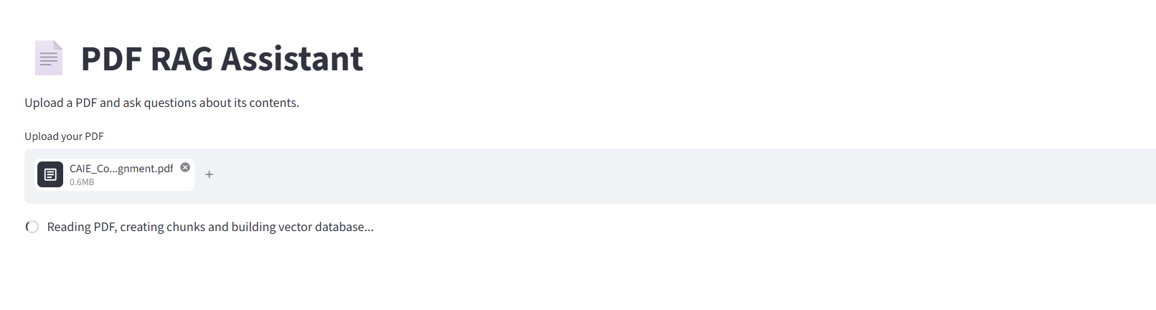
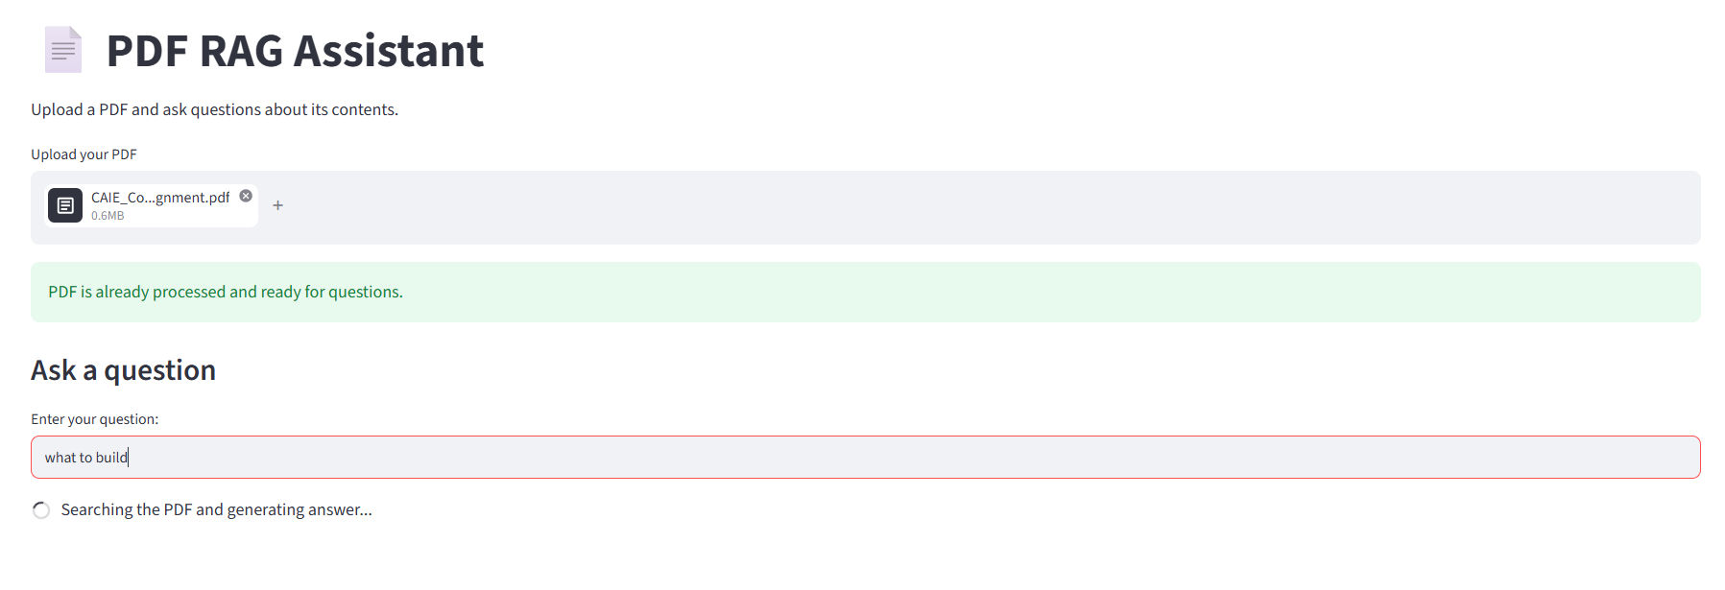
Answer retrieved:
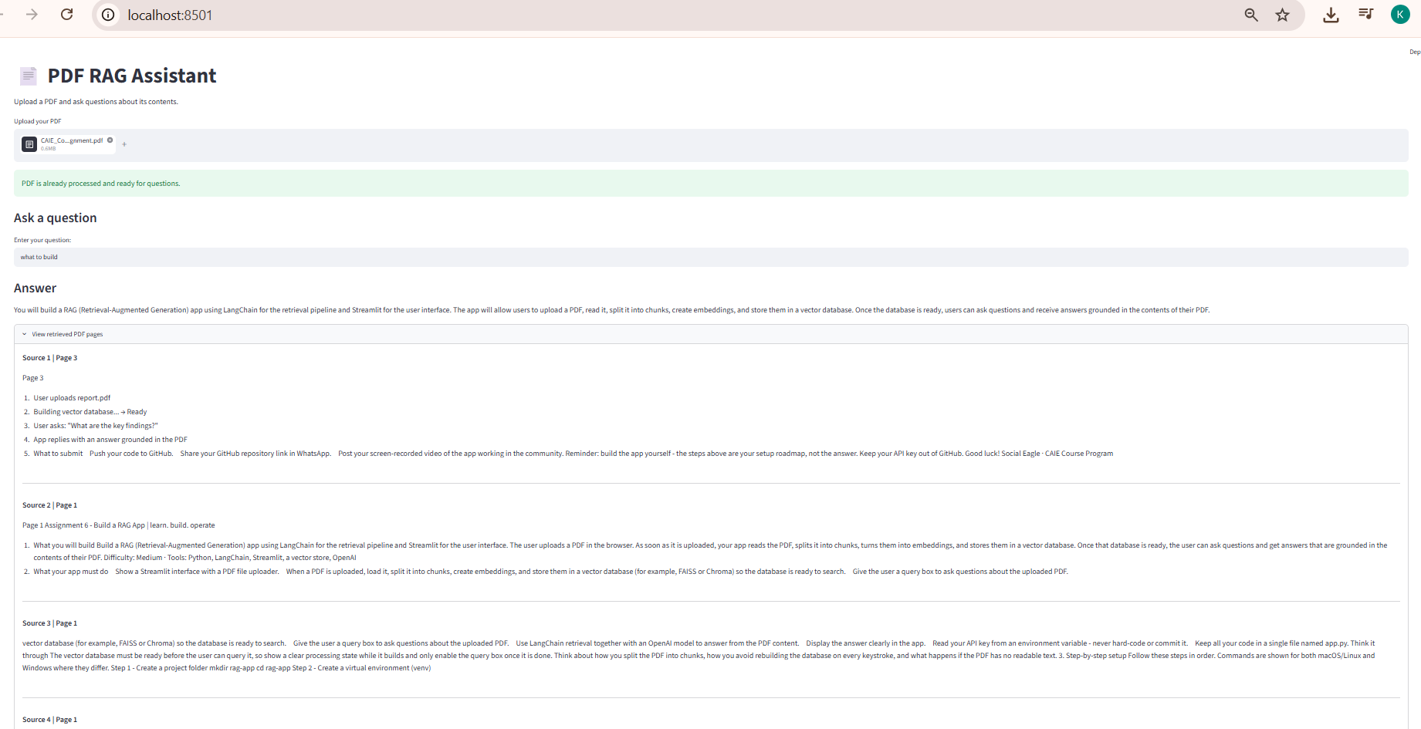

Vector Store created in local:
